From: https://davidstockmanscontracorner.com/here-comes-the-swans-black-red-and-orange/

---Black, Red And Orange!
By David Stockman. Posted On Monday, December 2nd, 2019
Once upon a time there was something called Event Risk that hovered over the financial markets, as did an even scarier relative known as the Black Swan.
Apparently, no longer. The Fed has so completely destroyed honest price discovery and euthanized fear of risk so thoroughly that the End of Times itself would likely [e]illicit a new round of dip buying.
The fact is, Black Swans as well as Red Swans (and an Orange Swan, too) are circling everywhere. That is, there is virtually no reward left atop the Mother of all Financial Bubbles while staggering risks metastasize by the day. Yet the algos and day traders remain nonplussed owing to the delusion that the Fed and other central banks will never again allow markets to correct by more than a few percentage points.
So more gist for that delusion is the real sin of the Fed's latest abject capitulation to Wall Street's demands for juice. The $324 billion added to its balance sheet in the last 11 weeks cannot possibly alter the course of the nation's $21 trillion economy and the $85 trillion of global GDP in which it is intricately immersed.
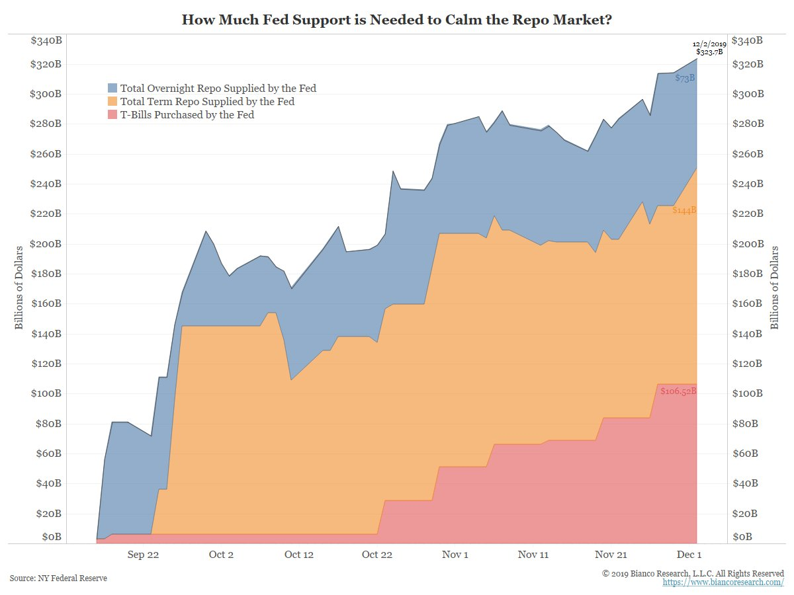
But it did fuel more stock buying by the algos, which, in turn, induced day traders and homegamers to hit the"buy" key without regard to anything except the Fed's own "buy" key thumping. Just on Friday and today, for example, the Eccles Building provided another $65 billion of 4-week term repo through year end at the bargain rate of 1.62%.
That's right. The Fed is furiously pumping money into the bond market so that that the dealer cost of carry for Uncle Sam's prodigious debts will remain at 74 basis points below the running inflation rate of 2.36% (16% trimmed mean CPI).
Still, there is no doubt as to where all this freshly minted liquidity went. To wit, it never left the canyons of Wall Street, and, in fact, since the launch of its "Not QE" $60 billion per month T-bill purchase program---on top of the new overnight and term repo facilities---the stock indices have moved higher every week save for the one week in mid-November when the Fed's balance sheet shrank by a smidgeon.
The absolute insanity of the Fed's latest Easy Money gambit---three rate cuts plus $324 billion of balance sheet expansion since late July---cannot be gainsaid. It is simply causing the financial bubble to reach an even more absurd aspect, thereby guaranteeing when it does eventually burst that the C-suites will launch into another "restructuring" frenzy--- throwing inventories, redundant workers and impaired assets overboard with malice aforethought.
That's otherwise known as the modern form of Recession that neither Wall Street nor the Fed heads ever see coming.
Then again, how could they?
Recessions nowadays are triggered by

- bubble collapses on Wall Street, not
- Credit Crunches on main street, as happened in your grandfather's economy.
So the Fed heads and their Wall Street masters never see it coming because recessions are embedded in central bank induced bubbles, but both Wall Street and the Eccles Building are utterly bubble blind.
Stated differently, what the Fed is actually doing in the name of extending the current crippled expansion is simply hyper-fueling the catalyst for the next financial crisis and its jarring spillover to the main street economy. It has actually done this twice already during the last two decades-----turbocharging both
- the dotcom and
- housing
bubbles in a manner that guaranteed the resulting main street contraction would be all the more painful.

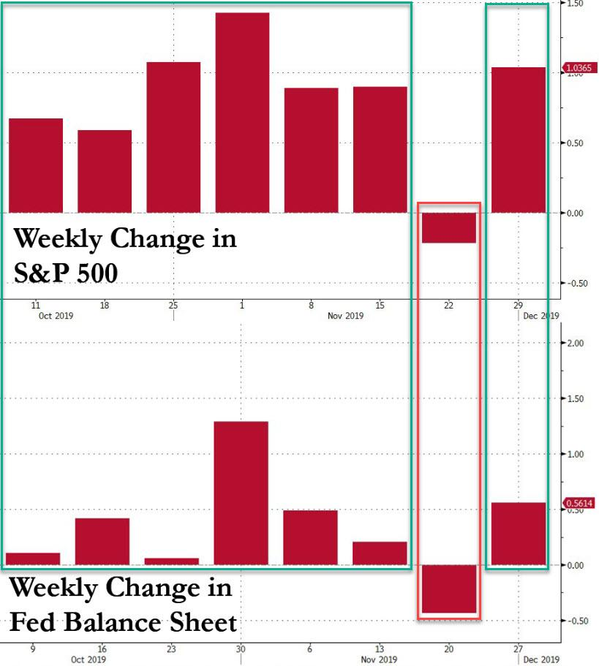
This time, however, the Fed has outdone itself. Even as it has inflated to the bubble to its finally truly incendiary extent, the main street economy both here and abroad has been visibly deflating, setting the stage for an extended recession that could go on far longer than ever before.
In the case of the US, for instance, the deflation of the broadest measure of main street economic activity---real final sales---is unmistakable. After peaking at 4.03% growth on a year-over-year basis in Q1 2015, the trend has been steadily downward.
Even the tax cut induced sugar high in Q3 2018, when the expansion rate temporarily accelerated to 3.49%, did not actually deflect the main street economy from its late-cycle deflating path. During Q3 2019, in fact, the 2.17% year-over-year growth rate was the lowest since early 2014.
To put it in the vernacular, the chart below is not a good look at all when you are at month #126 of a record long expansion and in a context where excess debt, rampant speculation, reckless leverage and sweeping malinvestment have reached unprecedented levels.
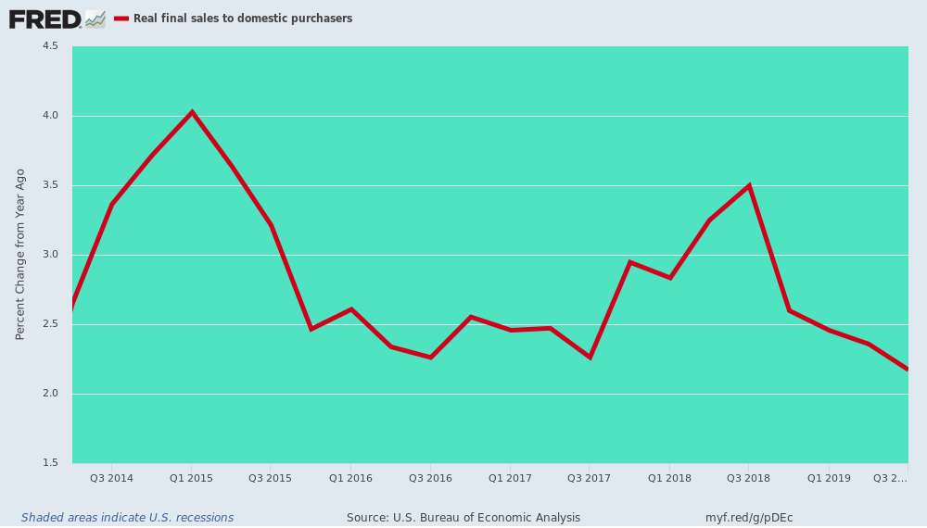
Moreover, aggregate GDP is a lagging indicator---the last macro-measure to get the word when the economy is pivoting toward recession. This morning, for instance, construction spending came in at -0.8% versus prior month, but more significantly, reflecting a descending path that speaks for itself.
Total private construction spending (brown line) turned negative on a year-over-year basis last November and in October was down 1.8% from prior year, and 7.5% from its February 2018 cyclical peak.
Likewise, the index for non-residential private construction---retail, offices, hospitality--- turned negative in May and is now down 5.4% from its year ago level.
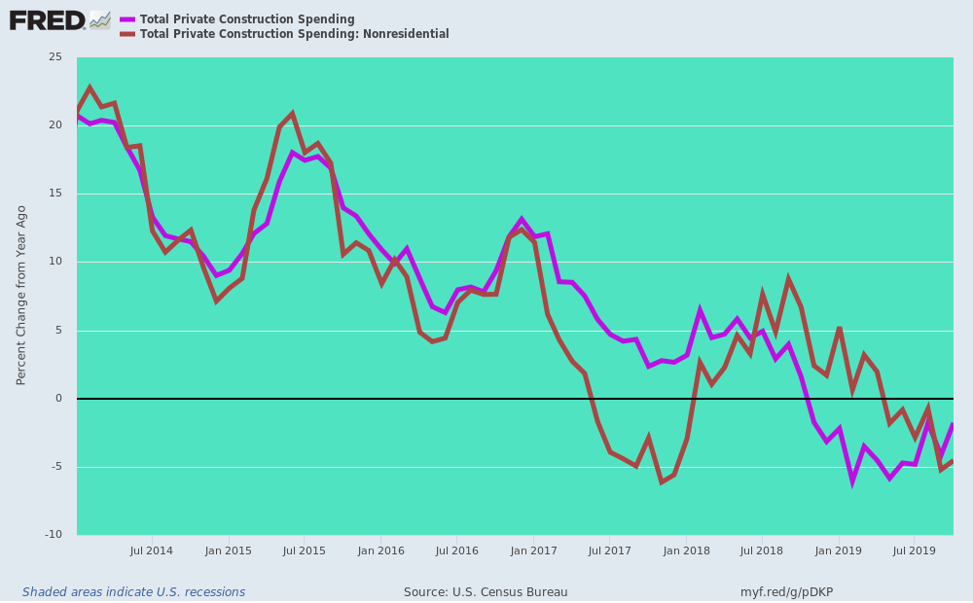
Needless to say, the October figures for industrial production reflected the same late-cycle growth rate deflation, with all major subcomponents now in negative territory. The change from October 2018 was:
- -4.11% for utility output;
- -2.47% for business equipment production;
- -2.16% for consumer goods production; and
- -1.13% for total industrial production including oil and gas drilling which is still slightly positive.
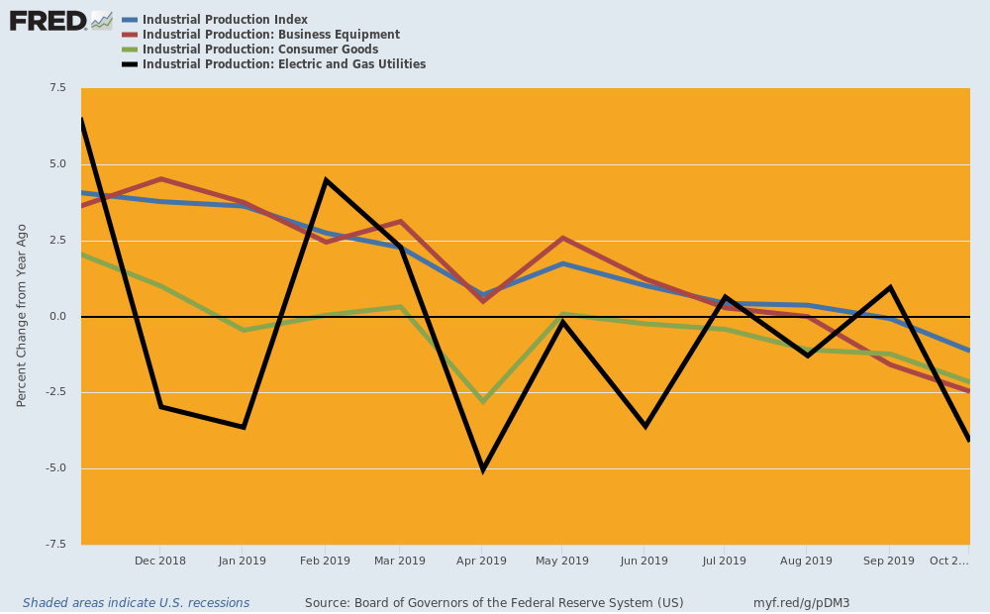
Nor is there much prospect that the vaunted labor market and relentless spending impulse of households will save the day. As we have previously demonstrated, what counts at this late stage of the cycle is labor hours, not headcounts.
Even then, labor hours are a lagging indicator, but they clearly remain hard upon a shrinking path. Compared to early 2018, labor hour growth has been reduced by upwards of 60%.
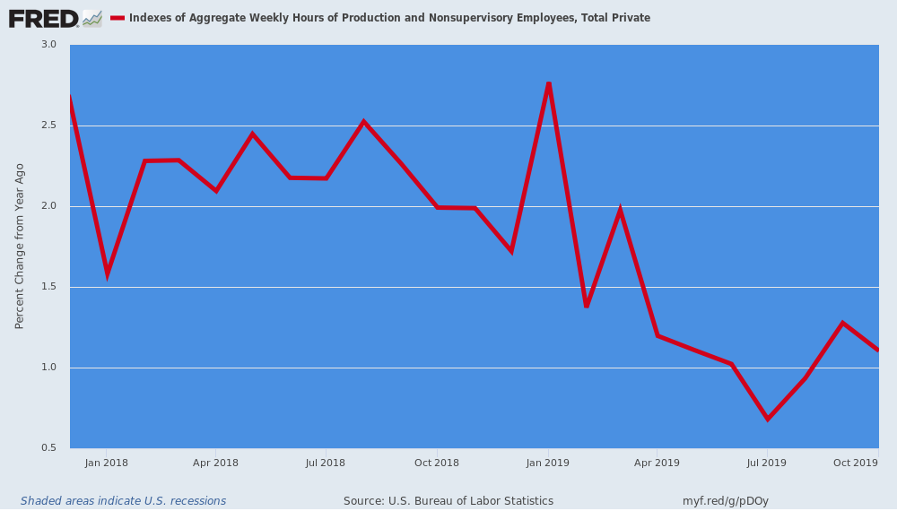
Accordingly, even household consumption spending (real PCE) continues to weaken. With 90% of US households at Peak Debt, there is no other source of spending wherewithal except the above faltering growth trend of labor income.
To wit, real PCE posted at just 2.32% on a year-over-year basis in October----and that's the last source of positive GDP momentum. Net exports and business CapEx have already rolled over.
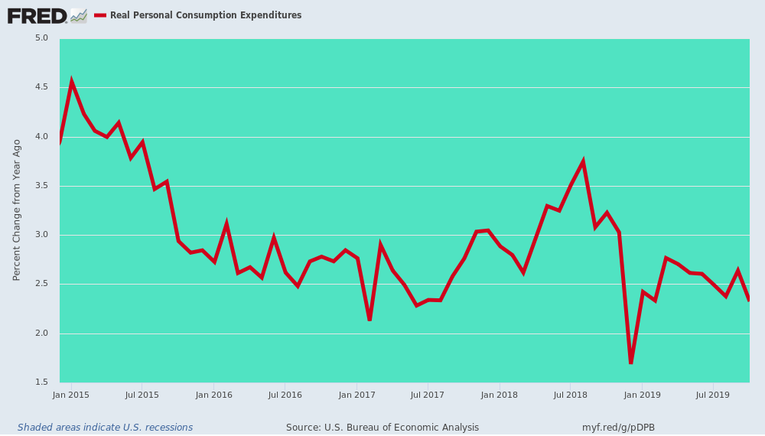
Indeed, in the case of net exports, the trend has been relentlessly from the upper left to the lower right ever since early 2014. As shown below in Q3 2019 the annualized rate of net exports has dropped from -$550 billion to -$988 billion or by 80%.
Stated differently, the main street economy is running out of steam. After any material crack in the stock market bubble, the C-suites of corporate America will perform their appointed catalyst function, triggering inventory, labor and asset liquidations which will send the main street economy the rest of the way into the drink.
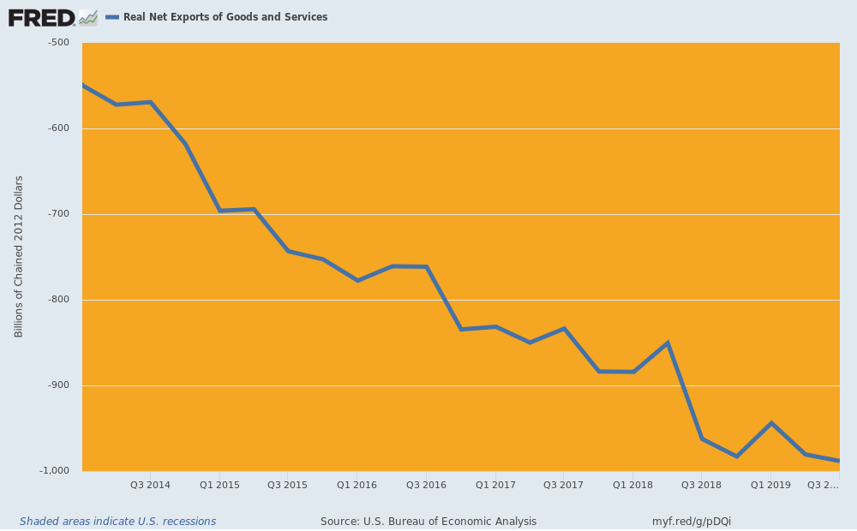
Along the way, they will get some major help from the Red Swan. That is, China's economy has been driven by debt accumulation and prodigious spending for fixed assets (FAI or fixed asset investment)---both industrial and public infrastructure. It was a giant Ponzi, of course, based on the erroneous notion that your can borrow and invest your way to sustainable prosperity---even if you are building the economic equivalent of pyramids and white elephants.
But even the Red Suzerains of Beijing now recognize that $41 trillion of bank debt alone on a $13 trillion economy is a recipe for disaster---even had it been spent on market-determined productive assets rather than empty airports, unused highways, bridges to nowhere, ghost cities, empty shopping mails and 65 million unoccupied apartment units. All of these will drag on the Red Ponzi for years to come while today's unsustainable debts come home to roost.
In any event, the slowdown trend is unmistakable and it is rapidly heading for crisis. During the most recent month, the year-over-year FAI growth rate slowed to 5%----representing the slowest rate since the early 1990s when Mr. Deng cranked up the printing presses in order to keep the communist party in power after Tiananmen Square.
Wall Street talking heads continue to maintain that the relentless deflation of China's FAI driver doesn't matter because the wise rulers in Beijing will deftly transition the Red Ponzi to a consumption and services based western style economy. Yet there is no logical or empirical reason to believe that is likely or even possible.
The motor force of China's economy is credit expansion, FAI spending, industrial production and then retail spending and Keynesian-style tabulated GDP. The second and third charts below, in fact, prove exactly that.
In a word, so goes FAI, so goes the Chinese economy, so goes global trade and production----and the direction of all is clear to see.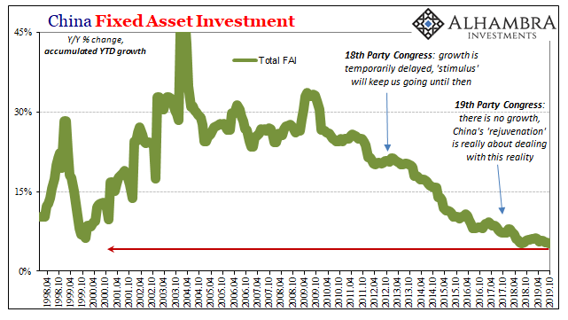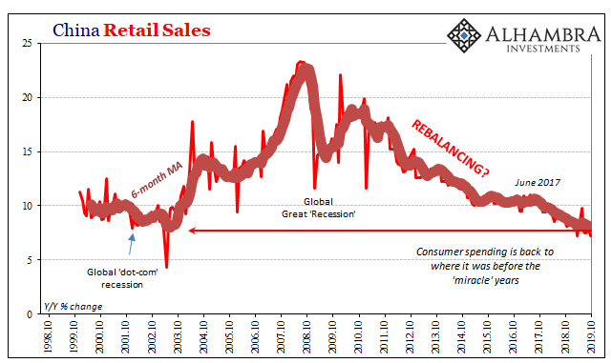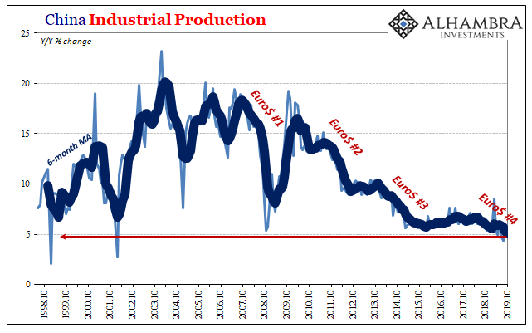
Finally, if the Blacks Swans circling Wall Street and the Red Swans hovering over the global economy were not enough, the Orange Swan has not yet begun to emit the mayhem we are quite sure is just around the corner.
Early this AM, in fact, he was out with a whole new theory of national economic policy. Namely, any nation foolish enough to let its FX rate slip against the dollar, can apparently expect to be hit with retaliatory tariffs, as was the case this morning with Brazil and Argentina.
The madness tweeted below is really all you need to know. The Orange Swan truly cometh.
Brazil and Argentina have been presiding over a massive devaluation of their currencies. which is not good for our farmers. Therefore, effective immediately, I will restore the Tariffs on all Steel & Aluminum that is shipped into the U.S. from those countries. The Federal Reserve should likewise act so that countries, of which there are many, no longer take advantage of our strong dollar by further devaluing their currencies. This makes it very hard for our manufactures & farmers to fairly export their goods. Lower Rates & Loosen - Fed!
U.S. Markets are up as much as 21% since the announcement of Tariffs on 3/1/2018 - and the U.S. is taking in massive amounts of money (and giving some to our farmers, who have been targeted by China)!
Well, what lies below is the accumulated rot of more than a decade of reckless monetary inflation.The two charts below are only indicative of the potential for financial disorder and breakdown which lies just around the corner.
